TASK # 01
Zain Ali (323)
AI (Lab)
Question 01:
Run the program below. Try different integer values, and note down what happens and any errors you need to fix: x = int(input("Please enter an integer: ")) if x < 0: x = 0 print('Negative changed to zero') elif x == 0: print('Zero') elif x == 1: print('Single') else: print('More')
What I did:
I wrote a Python program that asks the user to enter an integer and stores the input in a variable called `x`. Then, I used `if`, `elif`, and `else` statements to check the value of the number. If the number is negative, the program changes it to zero and displays a message. If the number is zero, it prints “Zero,” and if the number is one, it prints “Single.” For any number greater than one, the program prints “More.” In this way, I created a program that identifies and displays the category of the entered integer.
Code :
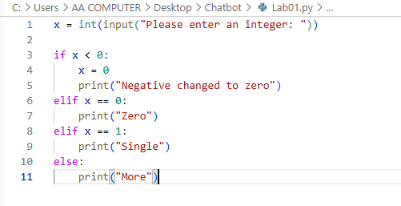
Explanation :
This code asks the user to enter an integer and saves it in the variable `x`. It then checks the number using `if`, `elif`, and `else` conditions.

- If `x` is less than `0`, it changes the value to `0` and prints **“Negative changed to zero.”**
- If `x` is equal to `0`, it prints **“Zero.”**
- If `x` is equal to `1`, it prints **“Single.”**
- If none of these conditions are true, the number is greater than `1`, so it prints **“More.”**

In short, the program checks the entered number and displays a suitable message according to its value.
Screenshot code running:
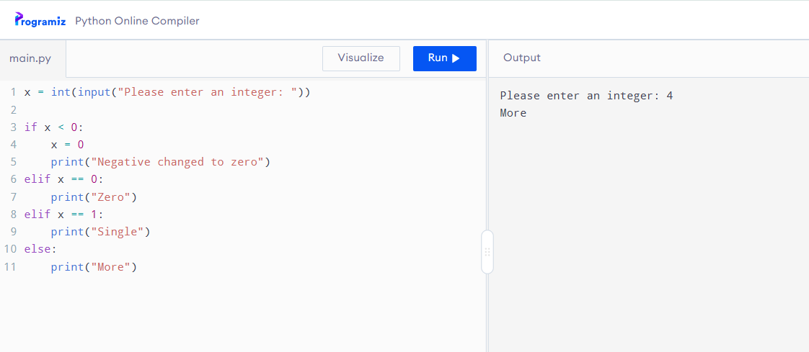
Question # 02:
Mini project (choose ONE): a. Dynamic calculator that solves an expression such as 1 + 2 × 3 (4 - 5 ÷ 4) - (3 ÷ 5) b. A dynamic To-Do list (add/remove/view items in a loop) c. Tic-Tac-Toe (two players, text-based) d. Hangman with a printed hangman figure that updates on wrong guesses
What I did :
I created a simple calculator program in Python. First, the program takes two numbers as input and stores them in the variables `a` and `b`. It also asks the user to enter an arithmetic operator, such as `+`, `-`, `*`, or `/`, and stores it in the variable `op`. Then, I used `if`, `elif`, and `else` statements to perform the selected mathematical operation. The program adds, subtracts, multiplies, or divides the two numbers according to the operator entered by the user. I also added a condition to check whether the second number is zero before division. If the user tries to divide by zero, the program displays **“Cannot divide by zero.”** If an invalid operator is entered, it displays **“Invalid operator.”**
Code screenshot :
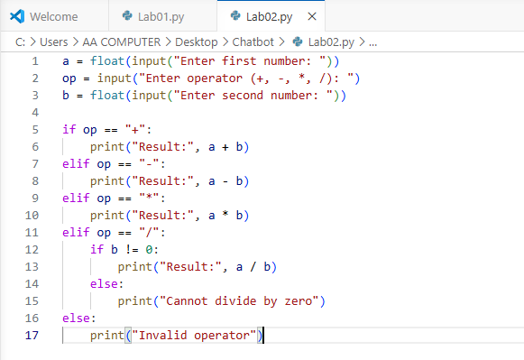
Code Explanation :
This code works as a simple calculator. It asks the user to enter two numbers and an operator. The operator tells the program which calculation to perform.

- `a` stores the first number.
- `op` stores the operator, such as `+`, `-`, `*`, or `/`.
- `b` stores the second number.

The program then checks the operator:

- If the user enters `+`, it adds the two numbers.
- If the user enters `-`, it subtracts the second number from the first.
- If the user enters `*`, it multiplies the two numbers.
- If the user enters `/`, it divides the first number by the second.

Before division, the program checks whether the second number is not zero. If the second number is zero, it prints **“Cannot divide by zero”** because division by zero is not possible. If the user enters an incorrect operator, the program prints **“Invalid operator.”**
Code Running Screenshot :
